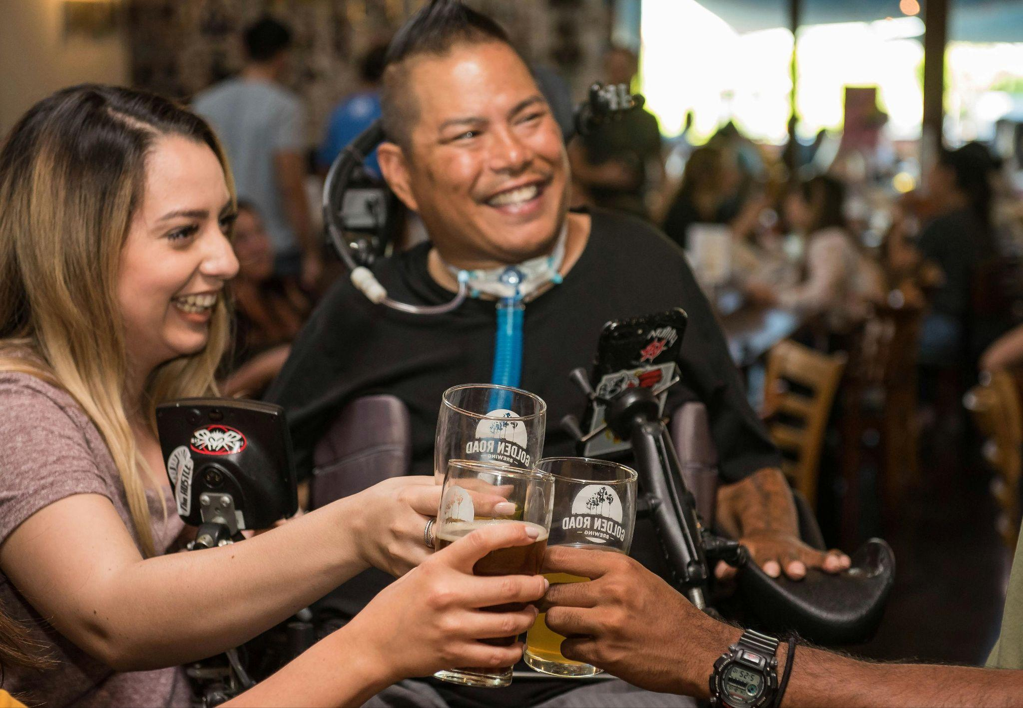
Image via Pexels
The Business Case for Accessibility: Why Inclusive Community Spaces Benefit Everyone
When you think of accessibility, the first image that likely comes to mind is a ramp or a reserved parking space. But accessibility is far more than that—it’s a holistic approach to designing community spaces and businesses that meet the needs of everyone, not just a few. By making inclusivity a foundational part of your physical layout, customer service, and workplace culture, you don’t just “do the right thing”—you make a smart investment. The business case for accessibility is real, measurable, and increasingly impossible to ignore.
Reaching More People Means Reaching More Potential
If your space is easy to navigate for someone using a wheelchair, it’s also easier for a parent pushing a stroller or an older adult with limited mobility. Accessibility expands your reach to groups that often get overlooked in traditional design: people with temporary injuries, people who are neurodiverse, or those simply navigating life with aging bodies. These are not niche groups—they represent a massive segment of the population with purchasing power and social influence. When your doors are open to all, your customer base grows in both size and diversity, creating a more robust and resilient business.
Money Moves Where Inclusion Lives
Communities thrive economically when everyone can participate. People with disabilities and their families tend to be more loyal to businesses that respect their needs, and they're more likely to frequent places that consistently provide accessible experiences. That means more dollars flowing into restaurants, retail shops, and entertainment venues that prioritize inclusive design. Multiply this across a city or neighborhood, and you’re looking at a serious bump in local economic activity—more jobs, stronger small businesses, and vibrant, connected communities.
A Reputation That Speaks Louder Than Advertising
In a world where consumers make decisions based on values as much as products, your reputation matters. Accessible businesses are seen as thoughtful, forward-thinking, and socially responsible—qualities that resonate with today’s buyers. People talk, leave reviews, and share experiences; when your business consistently meets or exceeds accessibility expectations, that word-of-mouth marketing becomes your greatest asset. Monitoring your brand’s reputation and using customer feedback to drive accessibility improvements isn’t just good practice—it’s a blueprint for long-term customer trust and loyalty.
Building Teams That Reflect the Real World
An inclusive business isn’t just one that welcomes all customers—it’s one that employs people from a wide range of experiences and abilities. Accessible workplaces enable people with disabilities to thrive, offering them not just employment, but dignity and agency. When employees feel valued and supported, they stay longer, contribute more, and bring fresh perspectives that can transform company culture. Diversity isn’t just a checkbox—it’s a driver of innovation, empathy, and resilience within your team.
Comfort Leads to Loyalty and Longer Visits
People go where they feel seen, supported, and safe. When your space accommodates diverse needs, visitors are more likely to stay longer, explore more, and return again. Maybe it’s a quiet room for someone with sensory sensitivities, or signage that’s easy to read for those with low vision. These details matter. And when people find a place that anticipates their needs instead of ignoring them, they not only come back—they bring friends, family, and recommendations with them.
Small Changes, Big Community Impact
Accessibility doesn’t only help people with permanent disabilities—it makes life easier for everyone. Wider doors, aisles, and hallways help people carrying groceries or wrangling toddlers. Clear signage helps tourists and new residents find their way. Thoughtful design transforms a place from functional to welcoming, signaling that all people belong there. As more businesses and spaces adopt these principles, entire communities become more connected, compassionate, and cohesive.
Rethinking the Future Through an Inclusive Lens
Accessibility isn't a checklist; it’s a mindset that touches every part of your business or public space—from design to policy to customer service. It's about anticipating needs, listening to feedback, and constantly evolving. It’s not about perfection—it’s about progress. And the businesses and organizations that commit to that progress are the ones poised to thrive in a future that values empathy, inclusion, and shared humanity.
When you invest in accessibility, you're not giving something away—you’re gaining something essential. You build a broader customer base, strengthen your economic impact, and create a reputation that resonates. You foster workplace diversity, invite people to stay and return, and help shape a community where everyone feels at home. Accessibility isn’t a special feature—it’s the foundation of spaces that work for people. And when you build with everyone in mind, everybody wins.

Article contributed by learningdisabilities.info

